20. Create a SQL storage service and perform a basic query using any Public Cloud Service Provider (Azure/GCP/AWS) to demonstrate Database as a Service (DaaS):

First you need to create an account on Microsoft azure…

Then after choose<<SQL databases>>and click on <<create>>

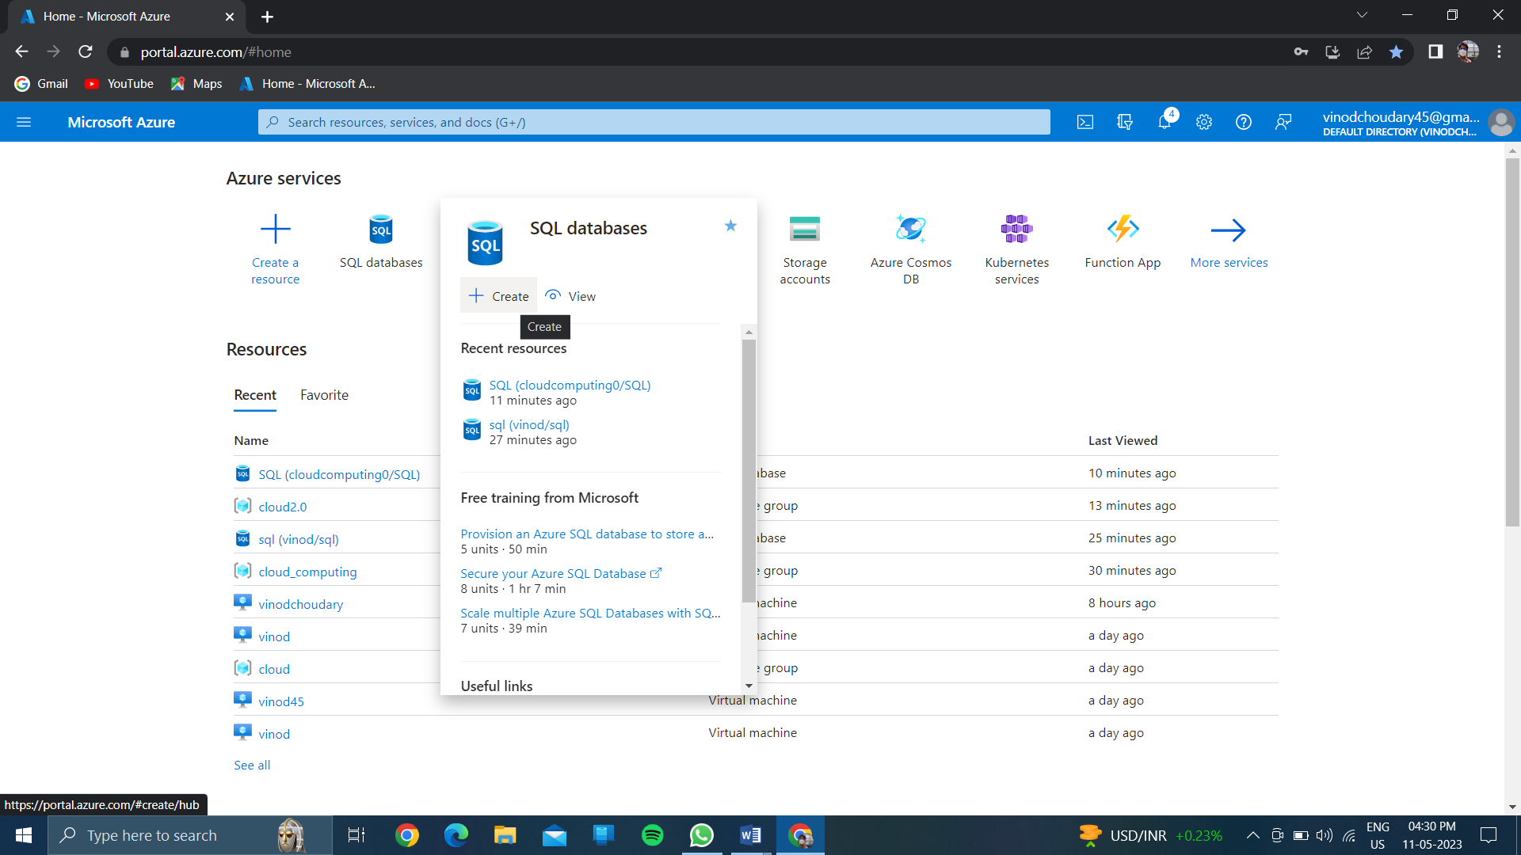

Give the resource group name:

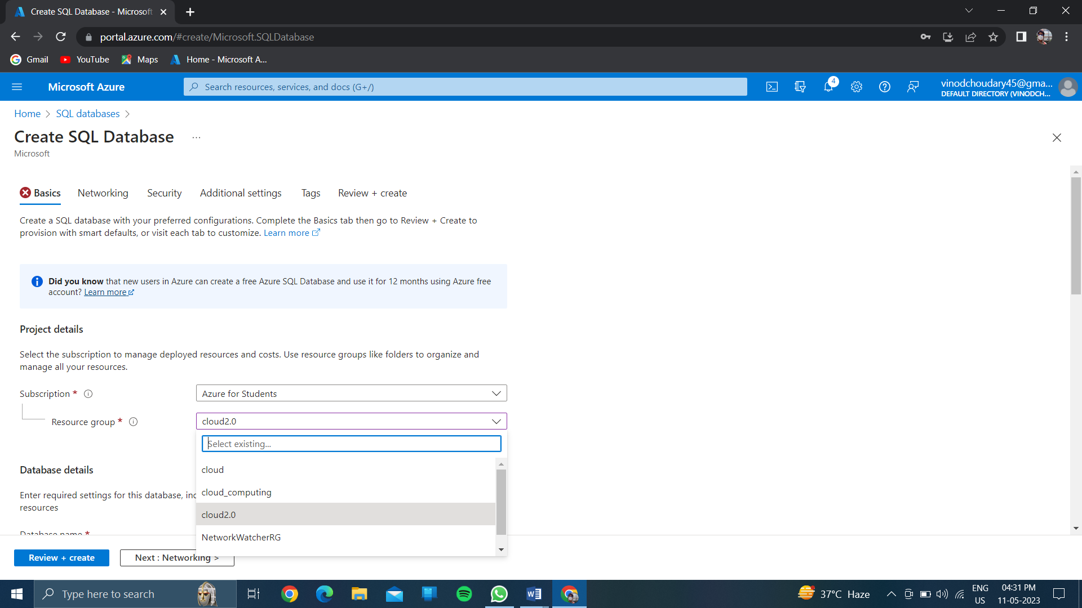

CREATE A DATABASE NAME:

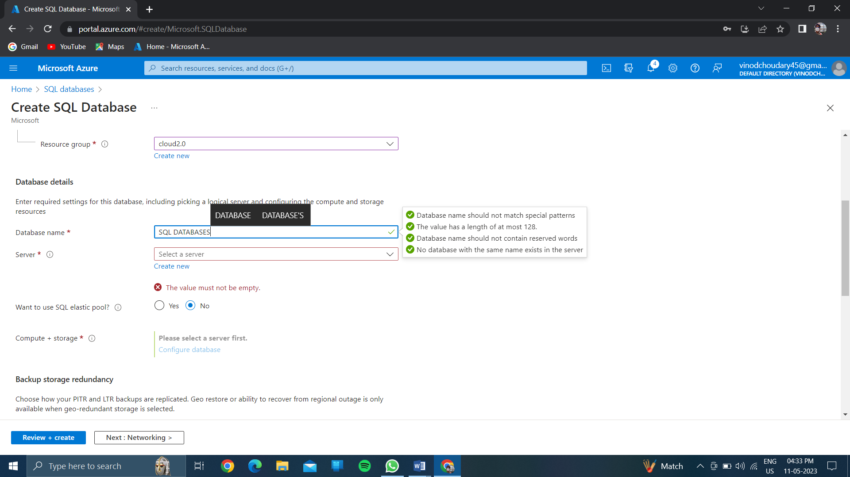

>>CLICK ON CREATE A SERVER….

>>give server name and location…..

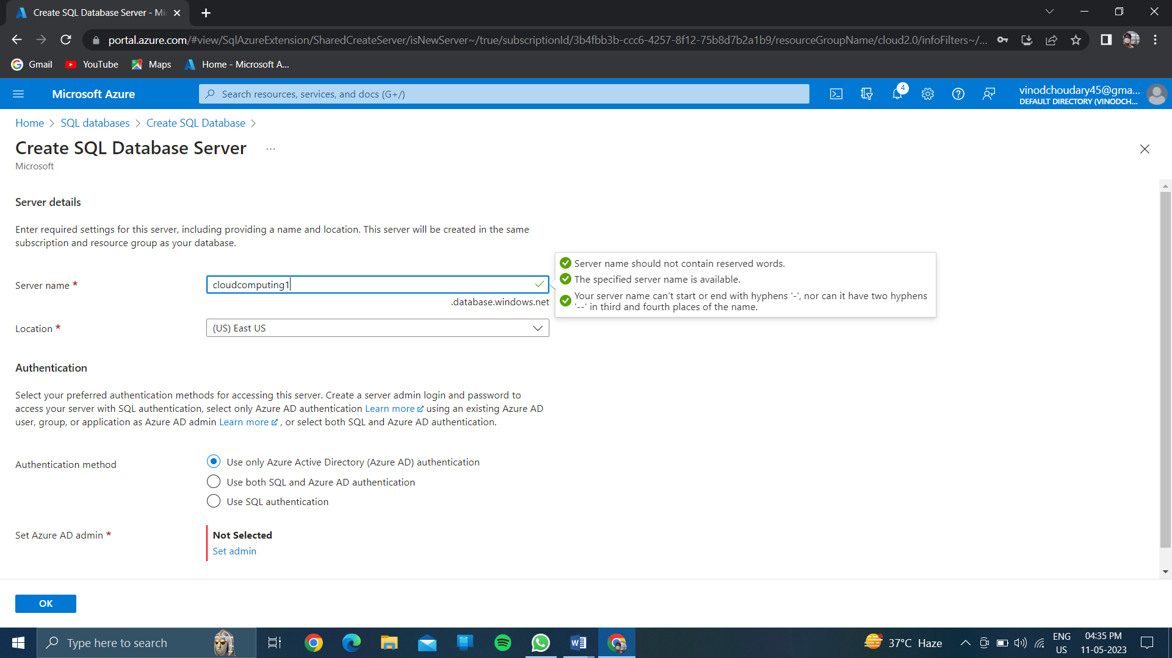

In authenticate method….

\*\*click on <<use sql authentication>>

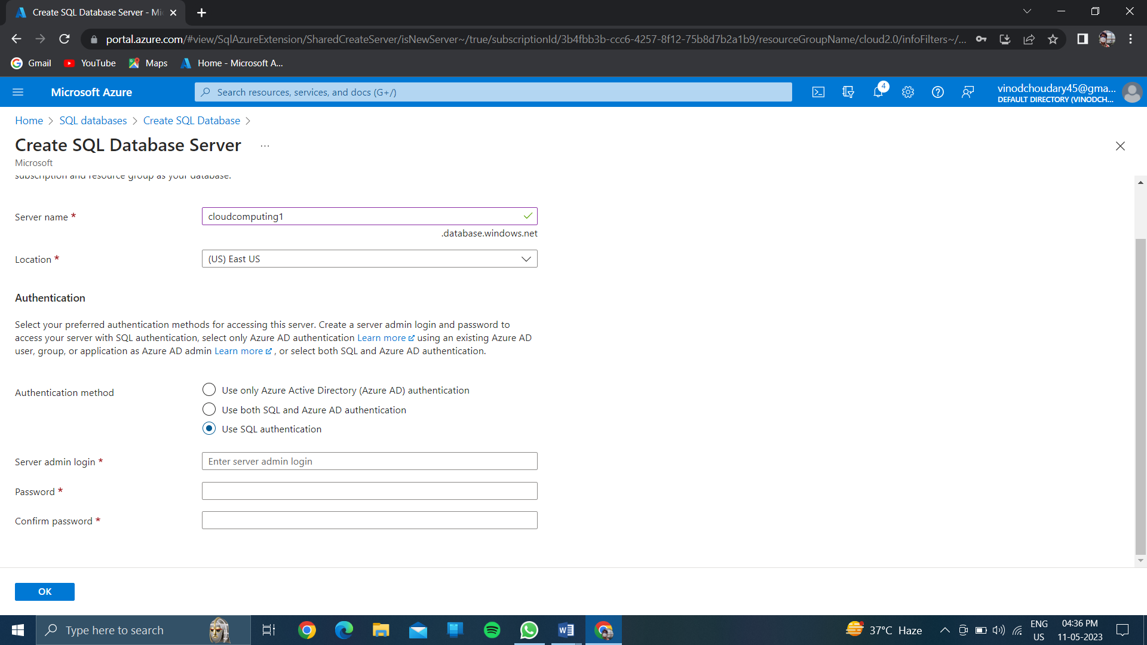

Create sql server admin& password….

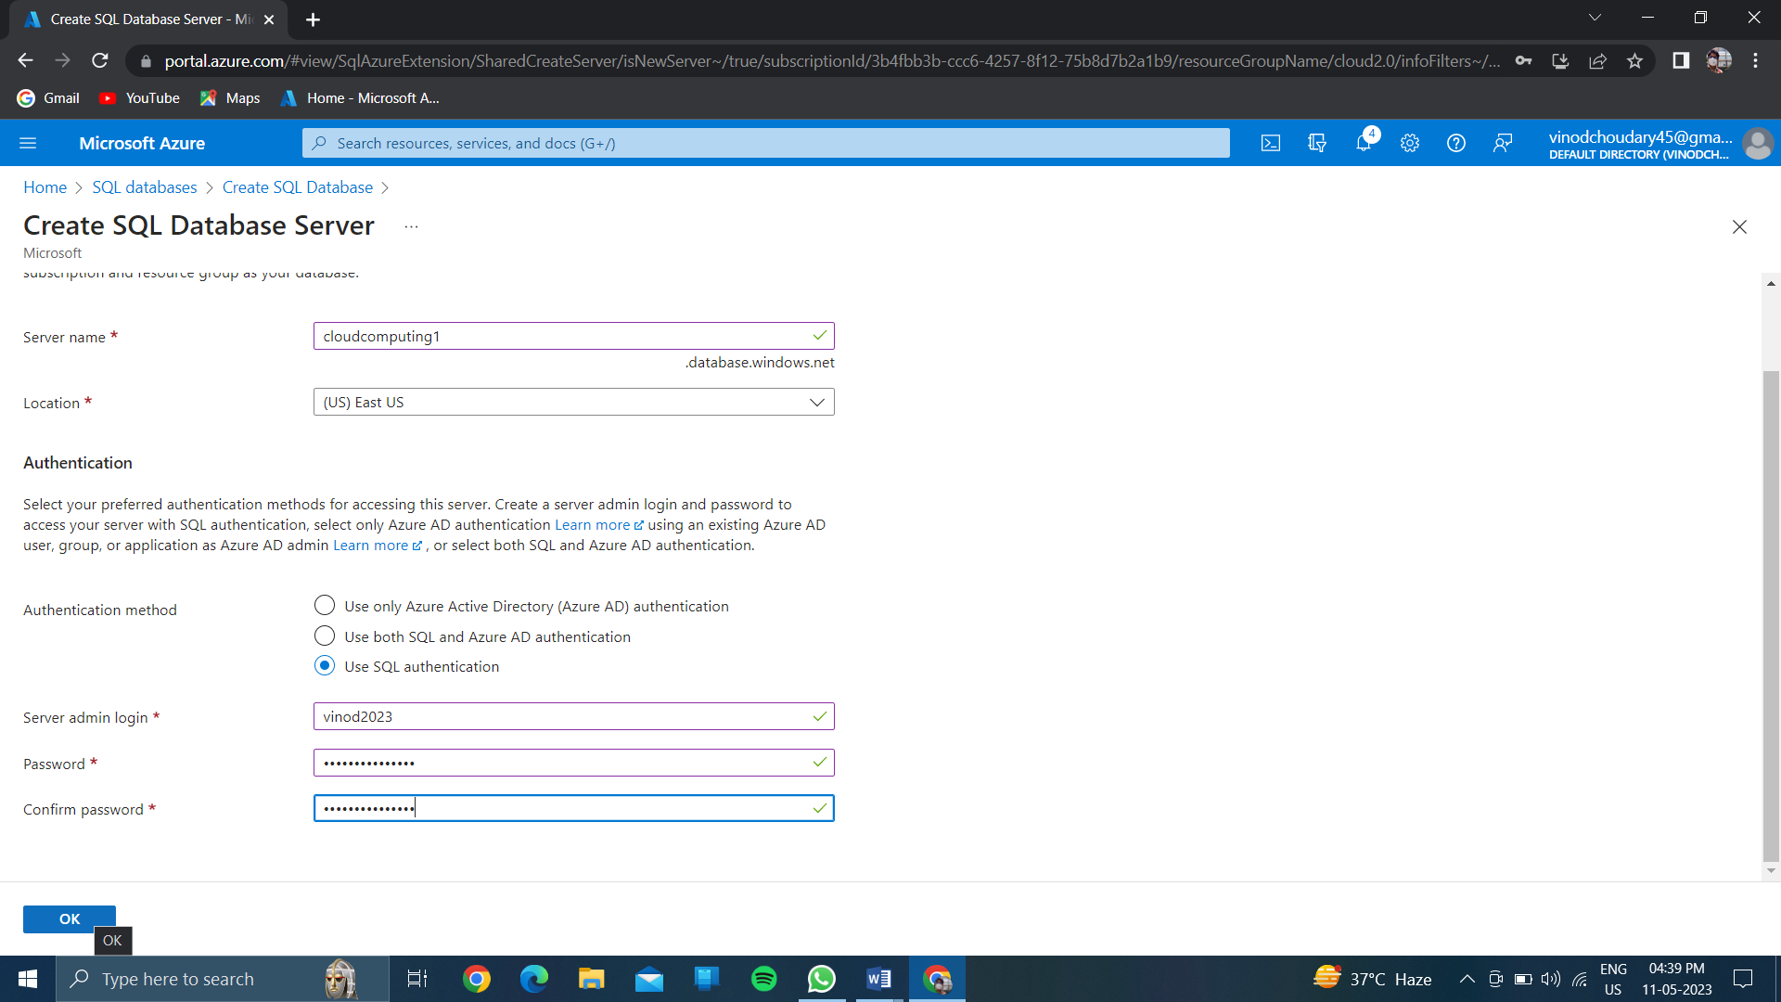

Then click on <<ok>>

>>THEN CLICK ON NETWORKING.

In connective method<<click on “public end point”>>

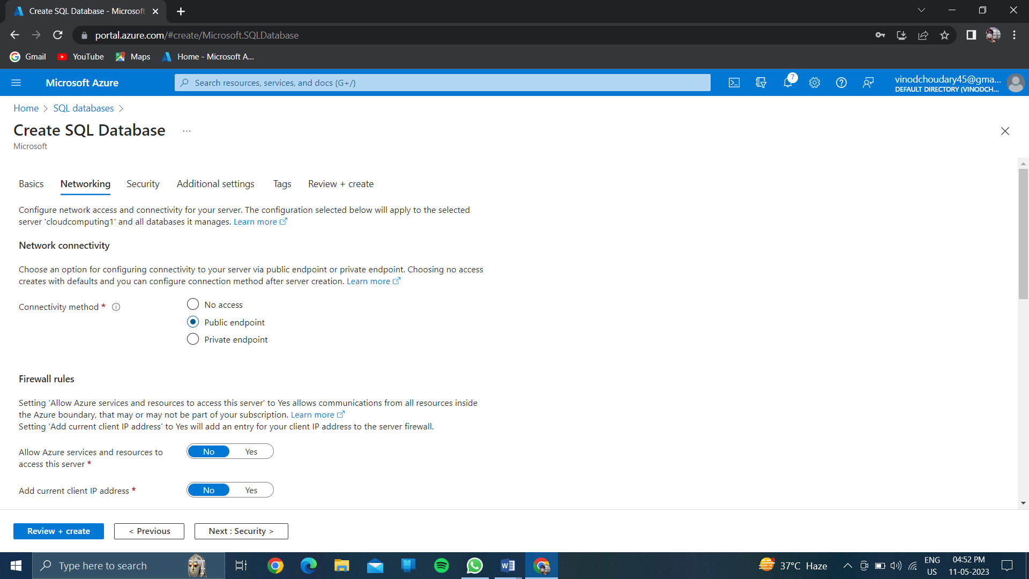

<<click on “yes” of allow azure servicesand resources to acess this server….

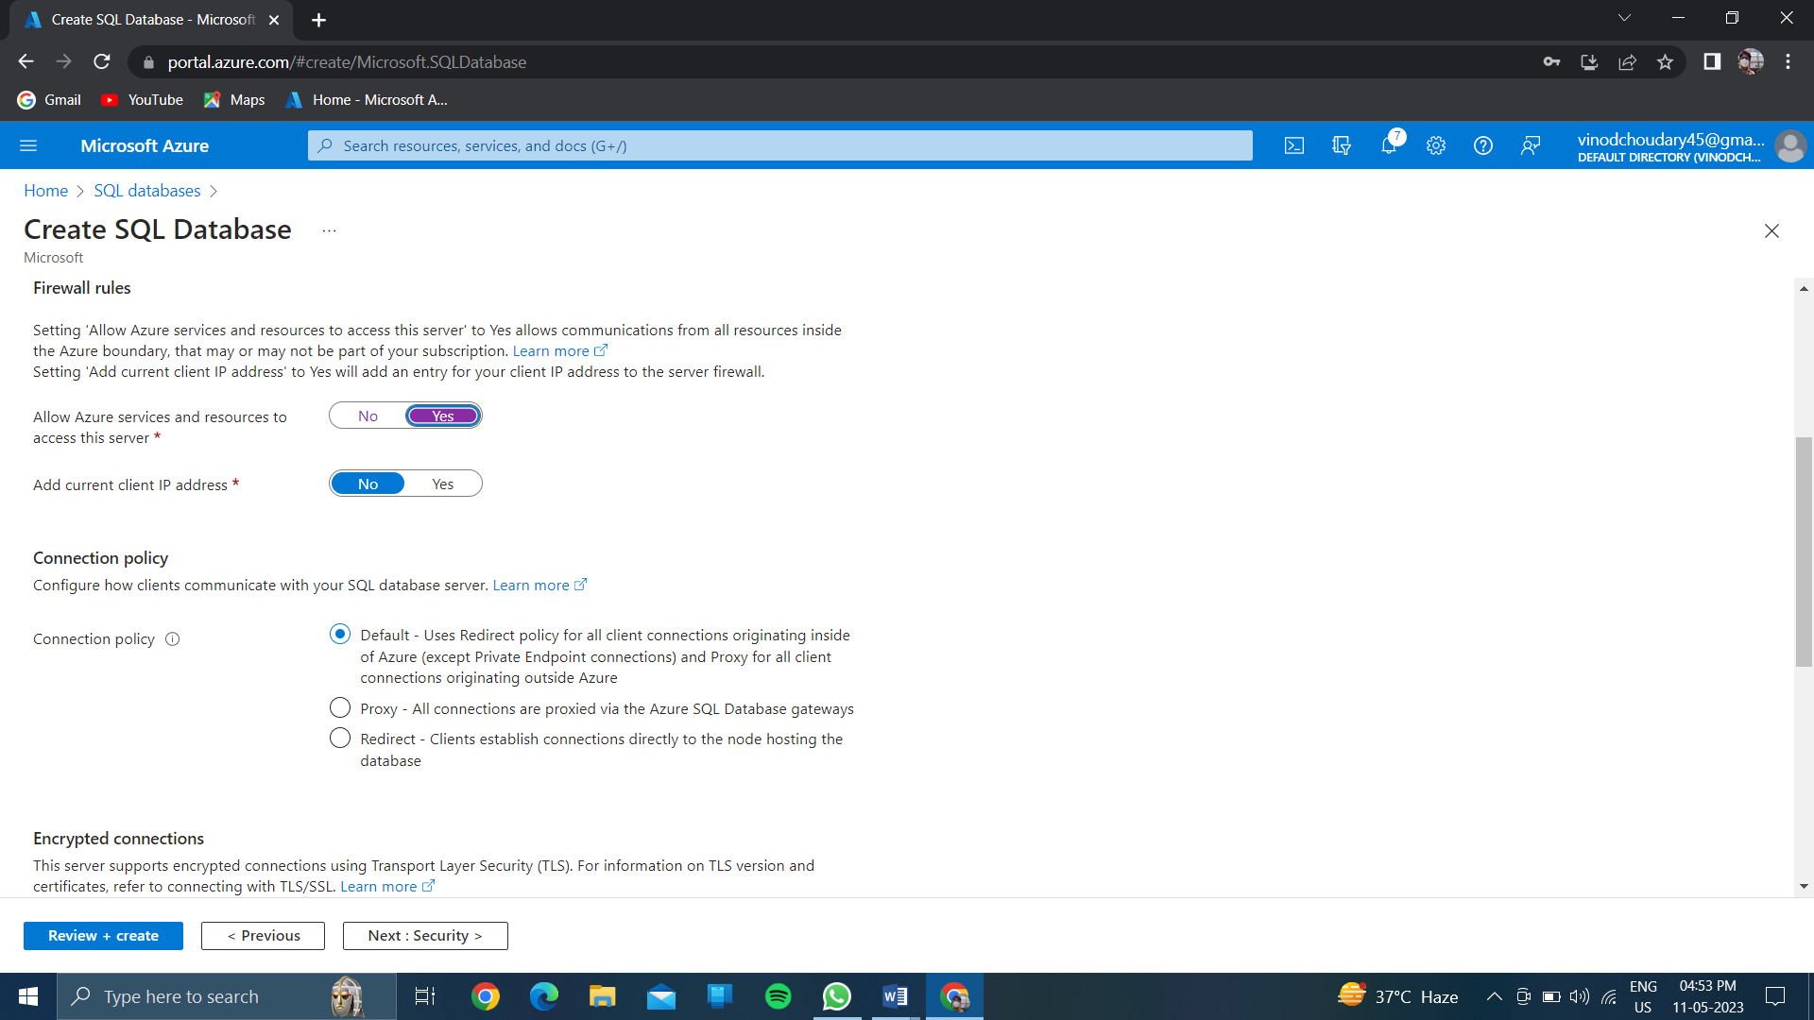

<<click on next—security>>

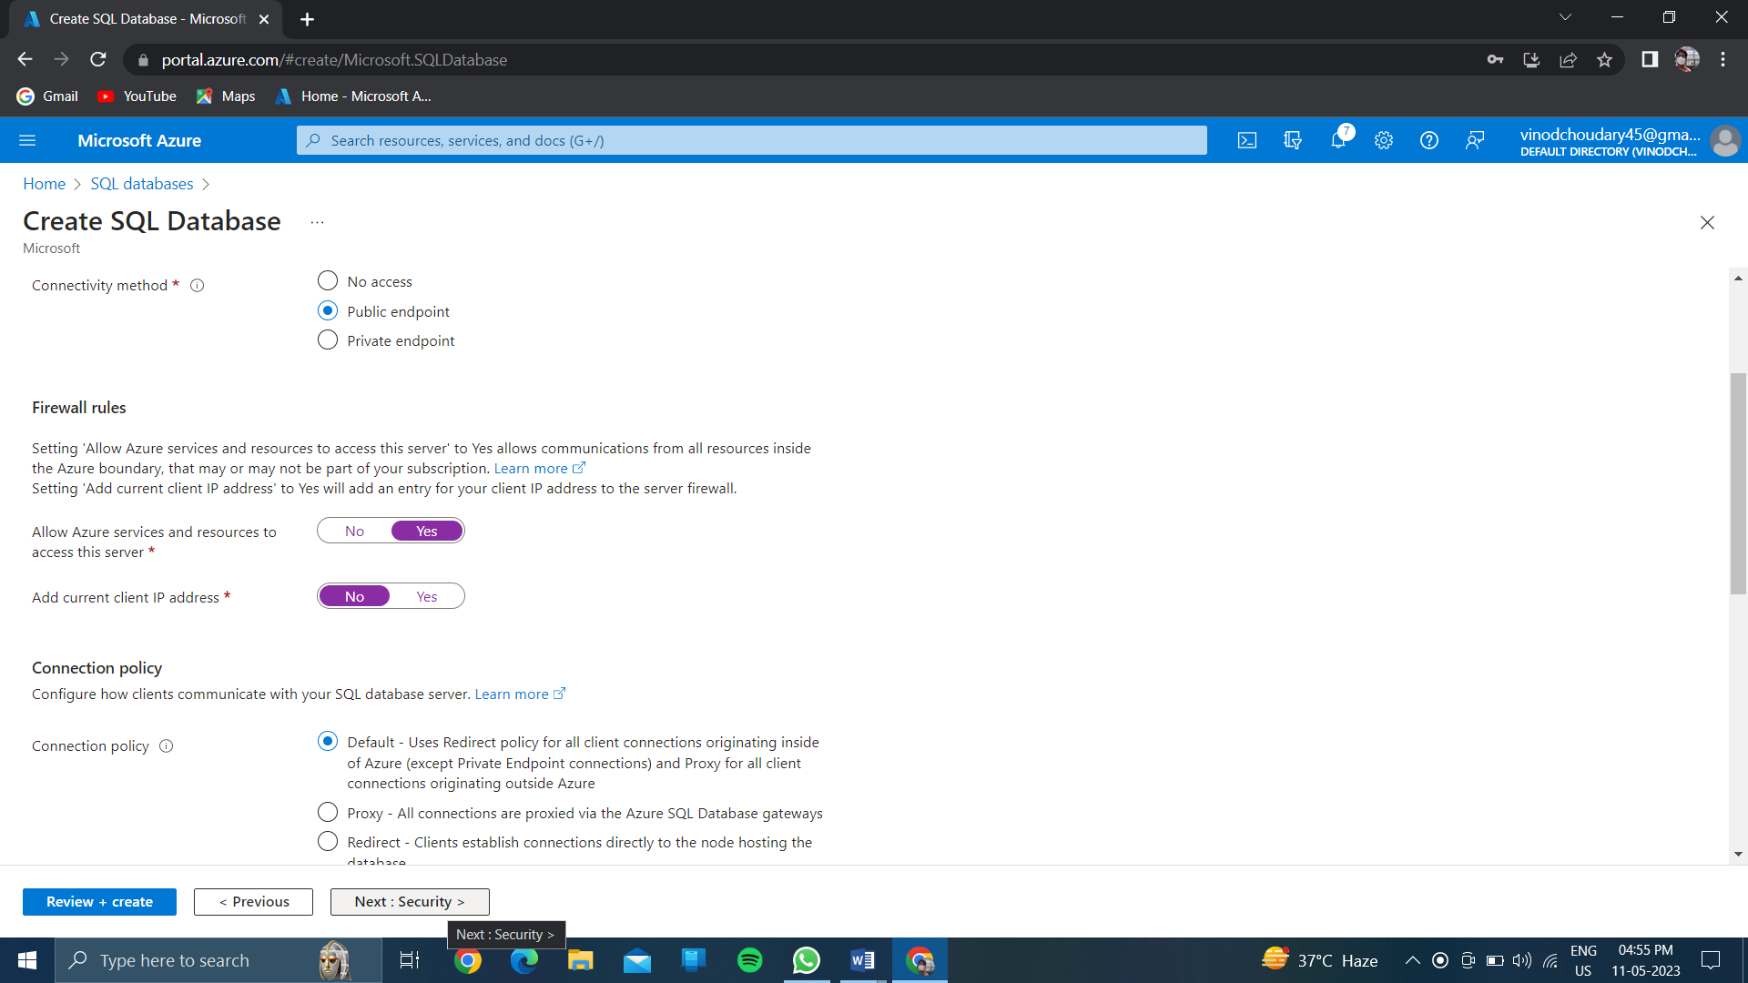

And click on next of// additional settings//

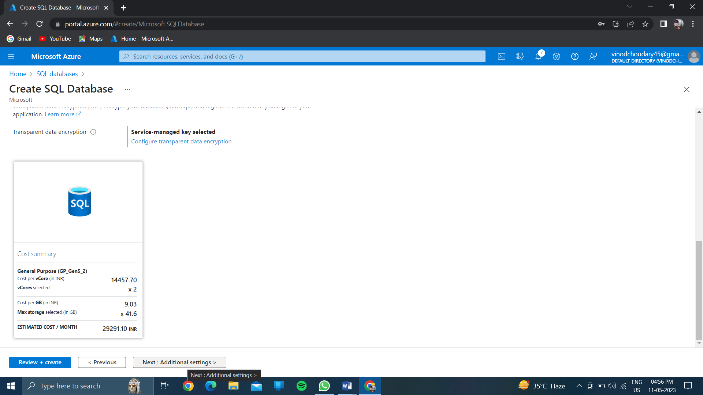

And choose <<sample>>for using of existing data

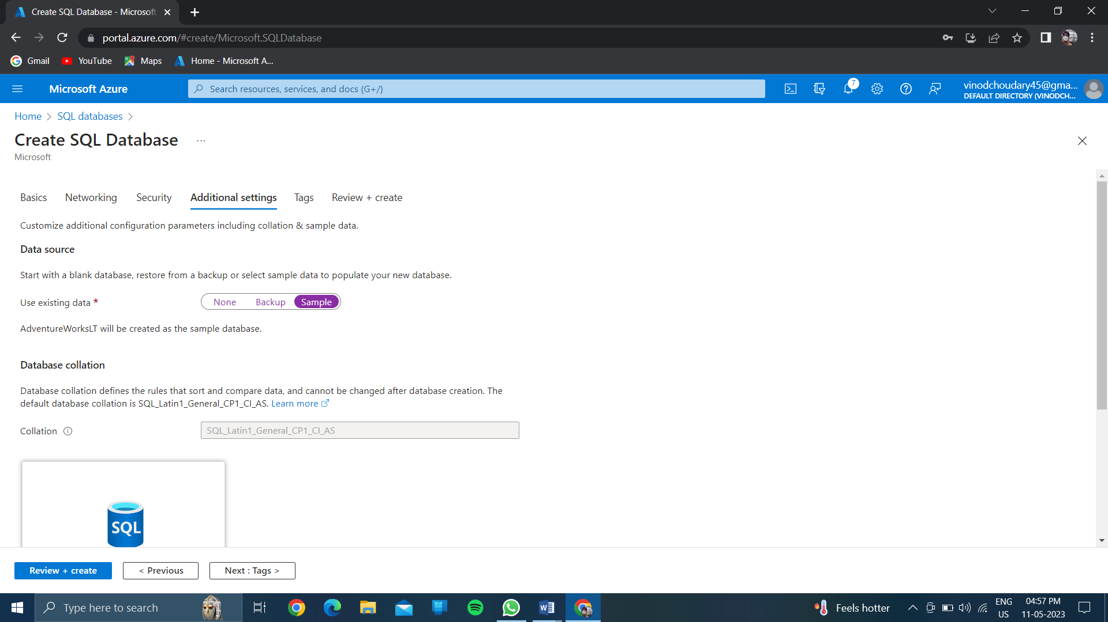

Click on //review and create//

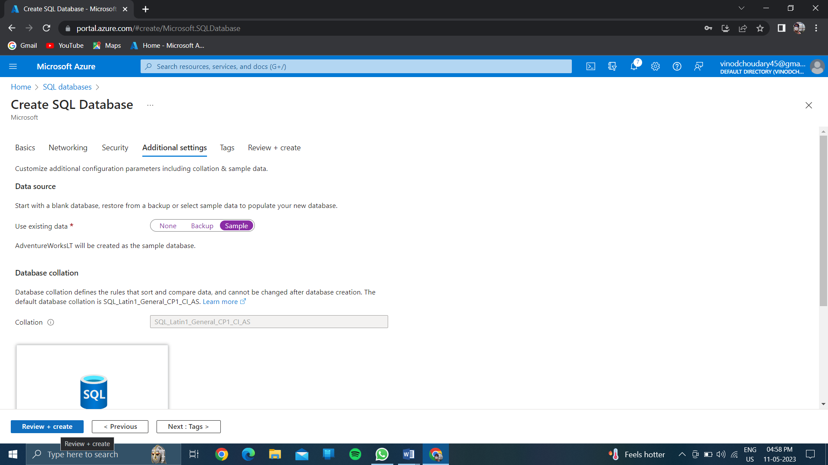

Then after “click on <<create>>”

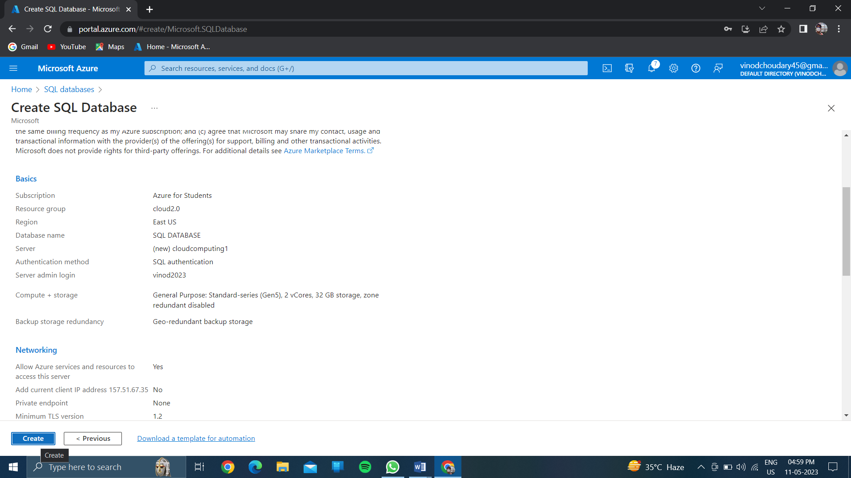

And wait for few minutes for validation & deployment.

After completing of deployment click on<<go to resource>>

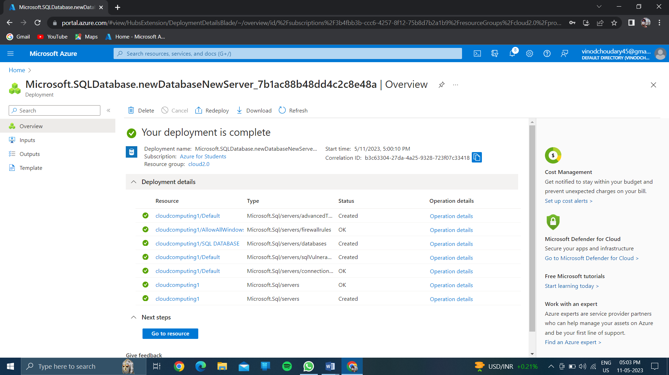

//on left side >>Click on <<query editor(preview)…

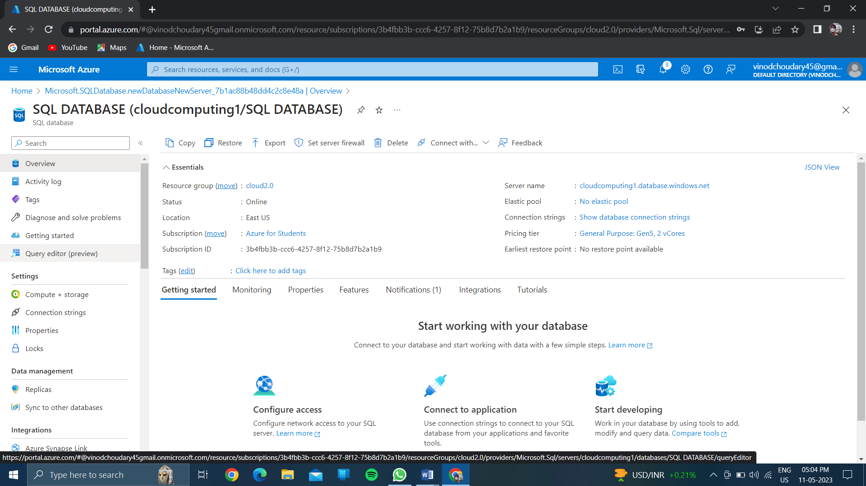

After then again login with username and password…………

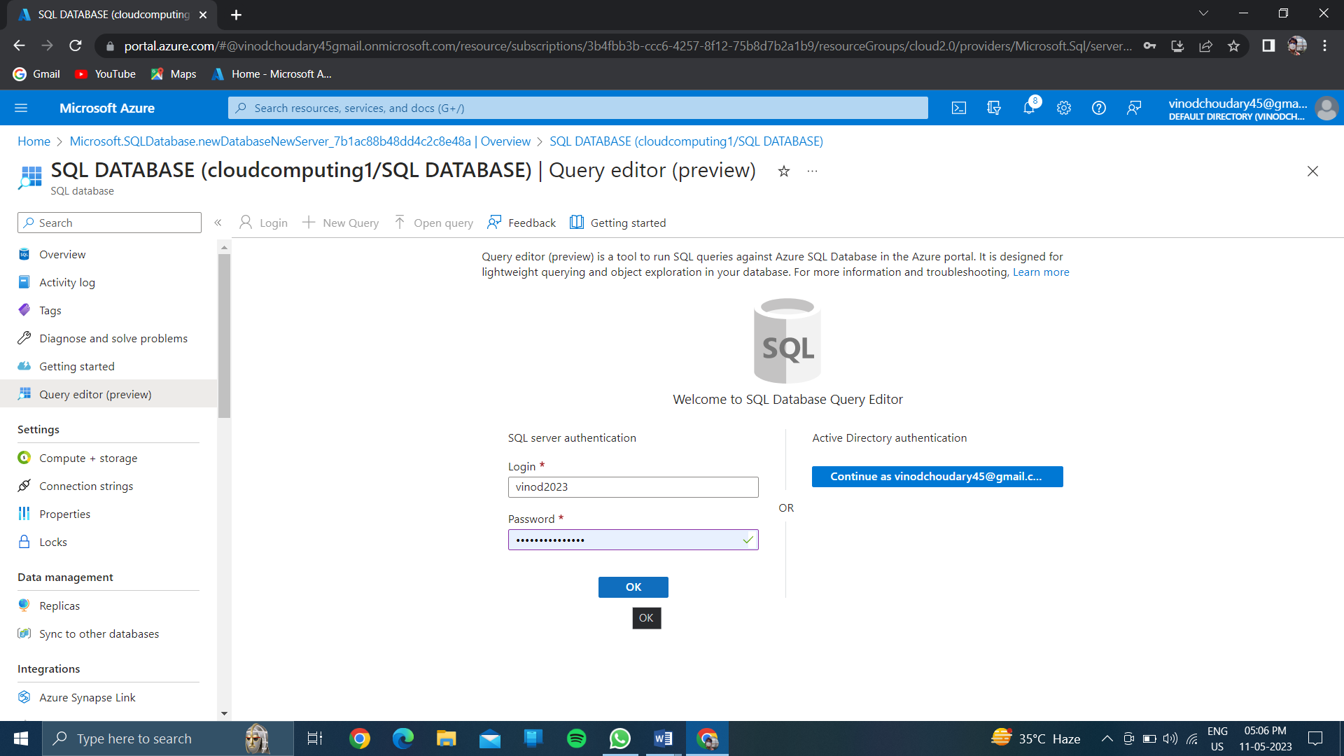

After then click on tables……

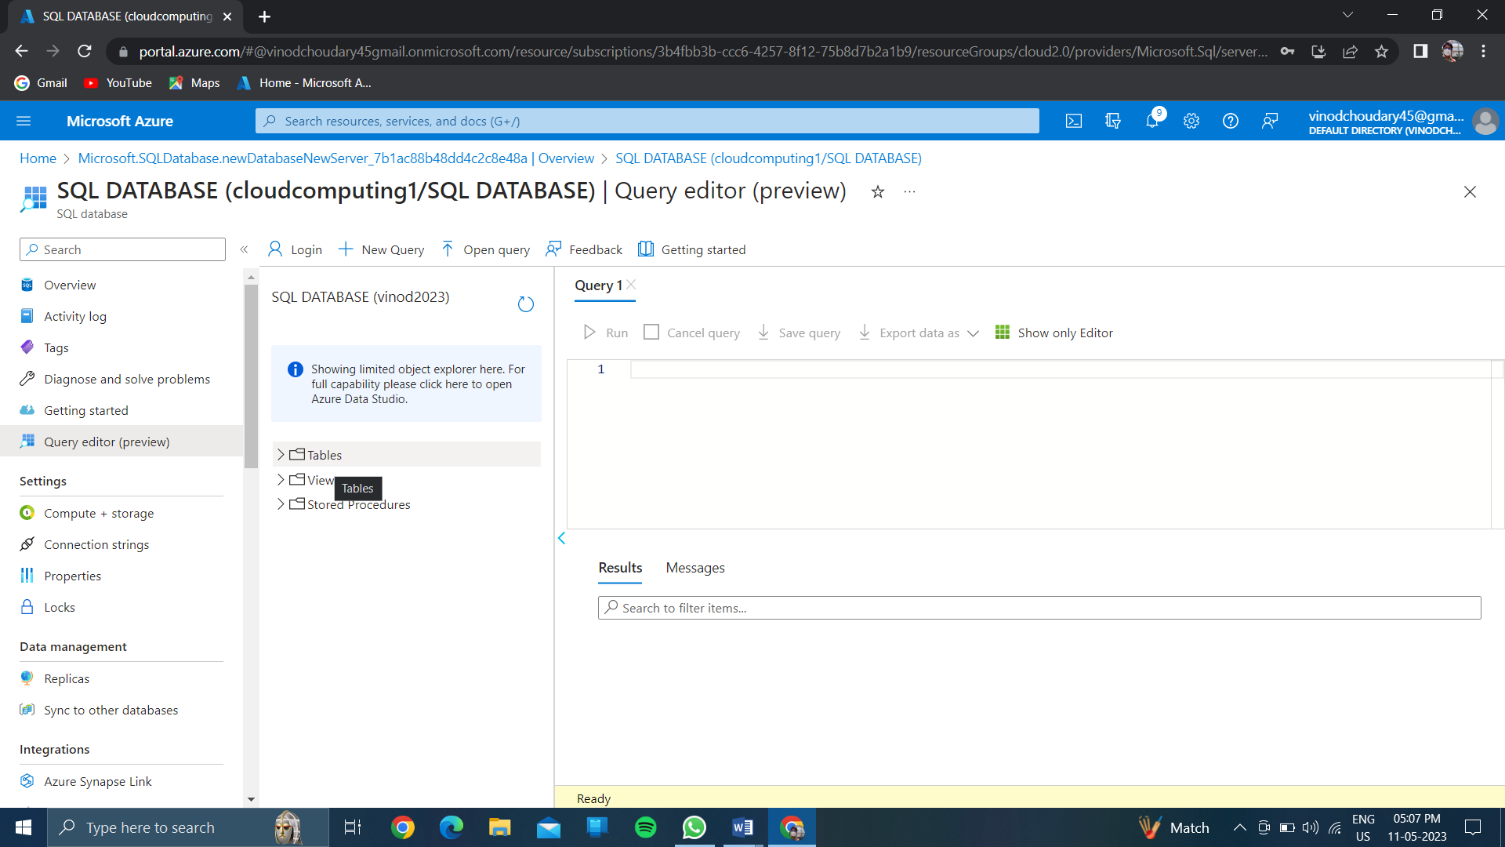

Then after click on sql build databases

The sql query language will be created and in bottom the output will be created……

